Lab Experiment: Remote Method Invocation (RMI)

Experiment No.: 8

Title: Implementation of Remote Method Invocation (RMI) in Java

Aim: To develop a distributed application using Java RMI where a client invokes methods of an object located on a remote server.

Objective:
- To understand the concept of distributed computing.
- To learn how Java RMI enables communication between remote objects.
- To implement client-server communication using RMI.

Theory:
Remote Method Invocation (RMI) is a Java API that allows an object residing in one JVM to access methods of an object running in another JVM. It enables distributed applications by allowing remote communication.
Key Components of RMI:
- Remote Interface: Declares methods that can be invoked remotely.
- Remote Object (Implementation): Implements the remote interface.
- RMI Registry: A naming service where remote objects are registered.
- Client: Looks up the registry and invokes remote methods.
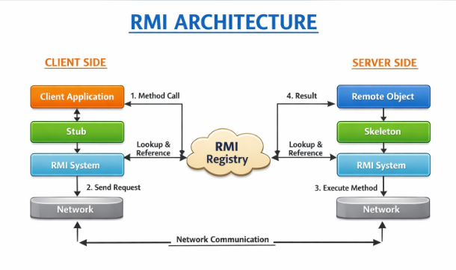

Software Requirements:
- JDK (Java Development Kit)
- Command Prompt / Terminal
- Any Java IDE (optional)

Step 1: Create a Folder
- Create a new folder (e.g., RMIProject)
- Open Command Prompt / Terminal and navigate to it: cd path_to_your_folder/RMIProject

Step 2: Create Java Files

Create the following files using Notepad / any editor:

Hello.java (Remote Interface)

import java.rmi.*;
public interface Hello extends Remote {
String sayHello() throws RemoteException;
}

HelloImpl.java

import java.rmi.*;

import java.rmi.server.*;

public class HelloImpl extends UnicastRemoteObject implements Hello {

protected HelloImpl() throws RemoteException {

super();

}

public String sayHello() {

return "Hello from Server!";

}

}

Server.java

import java.rmi.*;

import java.rmi.registry.*;

public class Server {

public static void main(String[] args) {

try {

HelloImpl obj = new HelloImpl ();

LocateRegistry.createRegistry(1099);

Naming.rebind("HelloService", obj);

System.out.println("Server is ready...");

}

catch (Exception e) {

System.out.println(e);

}

}

}

4.Client.java

import java.rmi.*;

public class Client {

public static void main(String[] args) {

try {

Hello stub = (Hello) Naming.lookup("rmi://localhost/HelloService");

System.out.println(stub.sayHello());

} catch (Exception e) {

System.out.println(e);

}

}

}

Step 3: Compile All Files

In terminal/command prompt:

javac *.java

Step 4: Start RMI Registry
Rmiregistry
(Keep this window open (do not close) )

Step 5: Run the Server
Open a new terminal window in the same folder:
java Server

Output will be:
Server is ready...

Step 6: Run the Client
Open another terminal window:
java Client

Expected Output
Hello from Server!

Conclusion:
The RMI application was successfully implemented, and the client was able to invoke a method on the remote server.
Java RMI enables seamless communication between distributed systems, allowing remote objects to interact as if they are local.

